**Machine Learning Engineer Nanodegree**

**Capstone Project**

Raphael Roullet  
December 1st, 2016

# I. Definition

## Project Overview

This project would be part of the domain of recommender (or recommendation) systems.

Recommendation systems are used to suggest items to users that they will like, based on different factors, increasing the chances that they perform an action with it (buying, watching…). With the increase of data on the web and the so-called long-tail, recommendation systems have become widely used to recommend different things: items on Amazon, news articles on Google News and music on Spotify…

Two main types of recommendation systems exist:

* Content-based: These algorithms use characteristics of items to make predictions
* Collaborative filtering: This type recommends items only based on the users past behavior. It is based on the principle that if someone with similar tastes than me has liked something, I’m more likely to like it as well.

Other types of recommendation systems exist and some, like Netflix’s, can take a hybrid approach.

This project however would take a different approach by *recommending users to other users* based on their similarity, a step that is part of collaborative filtering. Nevertheless, it would take a content-based approach by looking at the characteristics of the users, namely their interests. This project, indeed, aims at **recommending to users other users with similar interests, hobbies, passions…**

My personal motivation for this project stems from a desire to turn this project into an API that could be used through a mobile app that would also include messaging capabilities between users.

The ideal dataset would contain data about real people and their interests. We would need a list of users and for each one a list of their interests such that users would have interests in common. The bigger the dataset, the better since algorithms tend to perform better and better when given larger and larger datasets.

It turns out that this data can be found using the Meetup API. “Meetup is an online social networking portal that facilitates offline group meetings in various localities round the world.” On the platform, users can add interests to their profiles so that Meetup can recommend Meetup groups to join:

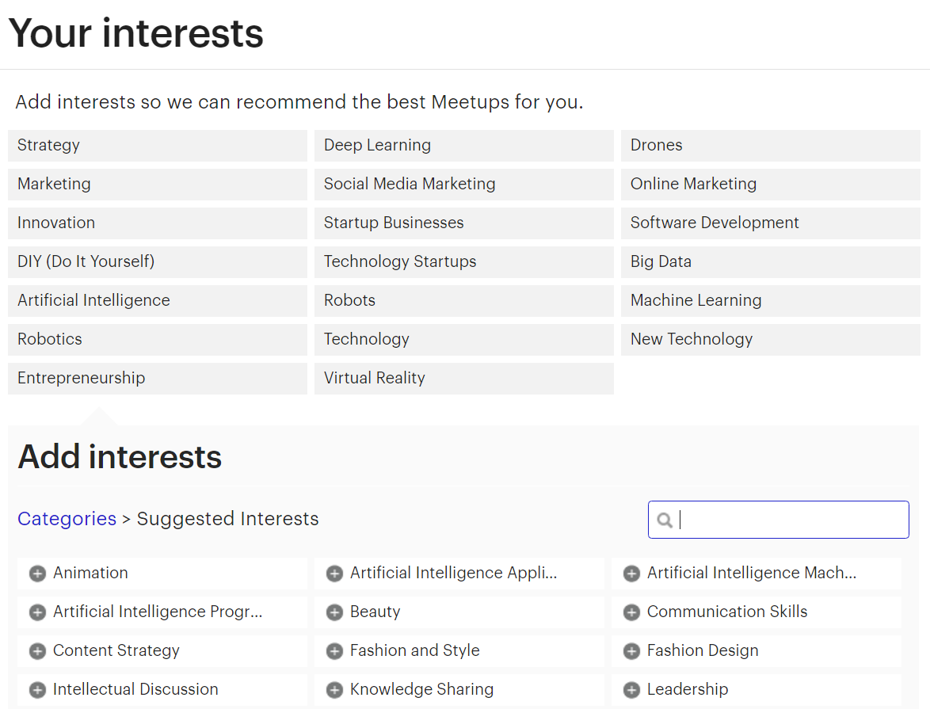

Using Meetup’s official API, 103,729 profiles of Meetup members were fetched in a 15-mile radius from Miami. Among these, **82,186 persons** had at least one interest indicated in their profile.

This data seems to be perfect to work with in order to solve our problem since it meets all the requirements mentioned above. It might be needed to ignore persons that don’t have at least a minimum number of interests indicated. In addition, only a subset of the 82,186 might be used because of constraints in terms of computational resources.

## Problem Statement

Given a dataset of X individuals and for each individual a list of n discrete interests from a finite universe of N interests, the problem is the following:

For a given individual how can we order the list of all the others X-1 individuals in descending order by similarity* of interests.

*Similarity can be defined using a measure like cosine similarity or by measuring the number of shared interests.

In order to recommend to users the 5, 10 or 20 users with whom they share the most interests we need to compute the similarity of their interests with those of all other users and then ranked users by descending similarity. By considering each list of users interests as documents the problem becomes one that appertains to the semantic analysis field which is well-documented.

The solution would then consist of using a similarity measure to compute the similarity between users’ interests (documents) after turning them into vectors.

## Metrics

Similarity can be tricky to define as it can be considered somehow subjective. However, in order to have quantifiable way to evaluate our model, two metrics will be used:

* The solution model and the benchmark model are expected to produce a measure of similarity for any given pair of users ($u_{x}$, $u_{y}$) as represented by a number between 0 and 1.
* The other metric used to evaluate the performance of both models will be determined by the number of interests that the queried person shares with the most matching persons returned, in absolute terms but also in percentage of her total number of interests.

# II. Analysis

(approx. 2-4 pages)

## Data Exploration

The dataset used for this project consists of profiles fetched from Meetup.com using Meetup’s API. First, it returned 1266 groups in a 15-mile radius from Miami. We then extracted 103,729 profiles, all members of these groups. Each data entry has the following features, selected among those provided by the API (<http://www.meetup.com/meetup_api/docs/2/members/>). Here’s an example for someone who really seems to like dogs.

{

'city': 'Miami',

'topics':

[

{‘name’: 'Pets', ‘urlkey’: 'pets-animals', ‘id’: 53052},

{‘name’: 'Dogs', ‘urlkey’: 'dogs', ‘id’: 15067},

{‘name’: 'Active Dogs', ‘urlkey’: 'activedogs', ‘id’: 9772},

{‘name’: 'Animals', ‘urlkey’: 'animals', ‘id’: 37663},

{‘name’: 'English Bulldog', ‘urlkey’: 'engbulldog', ‘id’: 560},

{‘name’: 'Off-Leash Dog Recreation', ‘urlkey’: 'offleash', ‘id’: 9753},

{‘name’: u'Pug', ‘urlkey’: 'pug', ‘id’: 591}

],

'link': 'http://www.meetup.com/members/111111111',

‘id’: 111111111,

‘name’: 'John Doe'

}

As seen above, each profile contains information about:

* **City**: Where the person is located
* **Topics**: What we will call interests. For each interest we have the name, urlkey (used to access it on Meetup.com) and unique id of the topic/interest.
* **Link**: towards the person’s profile on Meetup.com
* **Id**: Unique id of the person
* **Name**: Name of the person

Among all the information provided for each profile, only topics will actually be used to feed our algorithm. The rest is extra information that could be used for future reference.

Here are the first 10 profiles:

|  |  |  |  |  |  |
| --- | --- | --- | --- | --- | --- |
|  | **city** | **id** | **link** | **name** | **topics** |
| **0** | Miami | 1837039 | http://www.meetup.com/members/1837039 | ...Adeela! | [] |
| **1** | Miami | 50171992 | http://www.meetup.com/members/50171992 | "Jay" - Jennifer | [{u'name': u'Black Professionals', u'urlkey': ... |
| **2** | Miami | 203909843 | http://www.meetup.com/members/203909843 | Aaron Wallace | [{u'name': u'Pets', u'urlkey': u'pets-animals'... |
| **3** | Minneapolis | 145409602 | http://www.meetup.com/members/145409602 | abby | [{u'name': u'Pug', u'urlkey': u'pug', u'id': 5... |
| **4** | Miami | 201741842 | http://www.meetup.com/members/201741842 | abi | [{u'name': u'Artists', u'urlkey': u'boston-art... |
| **5** | Miami | 8484098 | http://www.meetup.com/members/8484098 | ADOLFO ROBIOU | [] |
| **6** | Miami Beach | 5694840 | http://www.meetup.com/members/5694840 | Aimee | [] |
| **7** | New York | 193427043 | http://www.meetup.com/members/193427043 | Alan Etienne | [{u'name': u'NFL Football', u'urlkey': u'nflfo... |
| **8** | Miami Beach | 32100452 | http://www.meetup.com/members/32100452 | Alan Rubio | [] |
| **9** | Miami Beach | 10645541 | http://www.meetup.com/members/10645541 | Alana and Max | [] |

From the first 10 entries we notice some discrepancies. Even though in our request to Meetup's API we queried only groups in a 15-mile radius around Miami, we notice some users, members of these groups, have a different city indicated in their profile. However, this doesn't interfere with our problem solution.

More importantly, we note that some users don't have any interest indicated on their profile. Therefore, they cannot be used for this project.

## Exploratory Visualization

Here are the most common interests among our dataset with their respective count:

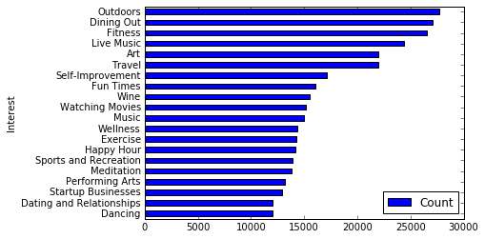

The top interests are not surprising: Outdoors, dining out, Music, Art, Travel, Fun times… are all very broad categories that are highly appreciated by most people.

There is a total of 21,892 unique interests.

How many interests do people have indicated on their Meetup profile? The following chart provides a good overview of the breakdown: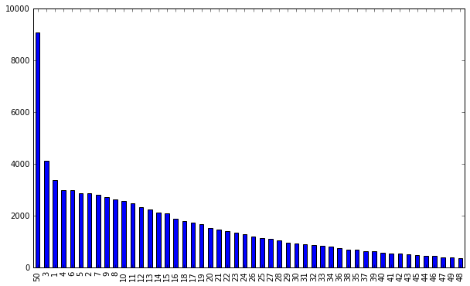

50 is the maximum number of interests you can select on Meetup and by far the most common number among our dataset followed by small number 3,1,4,6… up to 48 in almost ordinal order.

## Algorithms and Techniques

From the Meetup data as input, the approach taken would be that of treating each list of user interests as a bag of words (or “documents”): <http://scikit-learn.org/stable/modules/feature_extraction.html#the-bag-of-words-representation>

As opposed to some other documents, ours are already cleaned in the sense that there’s no need of tokenizing documents, removing common words (a, the, and …) and punctuation as it is often the case in NLP and semantic analysis.

The goal is to vectorize our corpus: turn each individual list of interests into sparse vectors using each interest as a feature. Scipy.sparse matrices will be used because for each person, the number of non-selected interests is huge, resulting in many features whose values are zero. This will give us a matrix Y where rows are users and columns are interests. Given the size of the corpus, it might even be wise to perform the hashing trick: <http://scikit-learn.org/stable/modules/feature_extraction.html#vectorizing-a-large-text-corpus-with-the-hashing-trick>

In analyzing corpuses, it is very common to use tf-idf. However, in our case term frequency is not relevant because each interest appears only once in each document. Inverse document frequency seems to be more interesting to explore since it would give a lower weight to interests that most people share and that by definition are not helping us better match people with similar interests.

With 21,892 unique interests, it might be interesting to try to reduce the vector space into a space of lower dimensionality. This might reveal some interesting associations between interests. Some transformations to explore include Latent Dirichlet Allocation and Latent Semantic Indexing (or Latent Semantic Analysis): <http://scikit-learn.org/stable/modules/decomposition.html#truncated-singular-value-decomposition-and-latent-semantic-analysis>

Finally, given a sparse vector X representing the interests of one person, I’d have to find the most similar vector among all the others. To do this, we would use cosine similarity (<http://scikit-learn.org/stable/modules/generated/sklearn.metrics.pairwise.cosine_similarity.html>) or Euclidean distance (<http://scikit-learn.org/stable/modules/generated/sklearn.metrics.pairwise.euclidean_distances.html>) to compute the similarity of each pair X and a vector of Y. Then results will be shown by descending order of similarity.

## Benchmark

In this section, you will need to provide a clearly defined benchmark result or threshold for comparing across performances obtained by your solution. The reasoning behind the benchmark (in the case where it is not an established result) should be discussed. Questions to ask yourself when writing this section:

* Has some result or value been provided that acts as a benchmark for measuring performance?
* Is it clear how this result or value was obtained (whether by data or by hypothesis)?

As a benchmark model we take the results obtained by using “gensim”, an excellent Python library made by Radim Řehůřek, which was designed to automatically extract semantic topics from documents: <https://radimrehurek.com/gensim/index.html>

Gensim can also be used to compute document similarity and output a list of documents ordered by similarity if given a query *or another document as a query* through its Similarities method that we proceed to implement:<https://radimrehurek.com/gensim/tut3.html>

It includes its own implementation of tfidf, LSA and cosine similarity. So, we first create a gensim corpus from the exact same corpus (our dataset of users interests).

Given that both the benchmark and solution model were given the same input, we will pick random users and compare what the two models return as the most matching users, i.e the vectors with the highest cosine similarities.

Here’s an example of output from the benchmark model with user #678:

[ (9499, 0.54554486274719238),

(6280, 0.53665632009506226),

(74350, 0.53665632009506226),

(11039, 0.52704644203186035)]

This is a list of the top 4 tuples containing user index and similarity score ranked in decreasing order of cosine similarity.

# III. Methodology

## Data Preprocessing

A couple of preprocessing steps were taken with this dataset.

From the Data Exploration section, we noticed that some users had no interest indicated in their profile so we remove these entries which can’t be used for this project. Among all the profiles, we’re left with 82,186 of them who had at least one interest.

I found out that it’s very important to re-index our dataframe after removing these entries in order to avoid having empty rows.

The list of interests for each user contains additional information that is useful but unnecessary for our algorithm like so:

[{u'id': 242, u'name': u'Fitness', u'urlkey': u'fitness'},

{u'id': 713, u'name': u'Dining Out', u'urlkey': u'diningout'},

{u'id': 1998, u'name': u'Travel', u'urlkey': u'travel'},

{u'id': 8652, u'name': u'Live Music', u'urlkey': u'livemusic'},

{u'id': 9696, u'name': u'New Technology', u'urlkey': u'newtech'}]

We create an additional column in our dataset that only contains the names of the interests and that we consider as “bags of words”.

## Implementation

In this section, the process for which metrics, algorithms, and techniques that you implemented for the given data will need to be clearly documented. It should be abundantly clear how the implementation was carried out, and discussion should be made regarding any complications that occurred during this process. Questions to ask yourself when writing this section:

* Is it made clear how the algorithms and techniques were implemented with the given datasets or input data?
* Were there any complications with the original metrics or techniques that required changing prior to acquiring a solution?
* Was there any part of the coding process (e.g., writing complicated functions) that should be documented?

We first implemented from scikit-learn a vectorizer that also included a TFIDF processor called TfidfVectorizer in order to extract all interests as features and turn our dataframe of “documents” into a sparse matrix.

One little change was about writing a custom tokenizer. Since vectorizers are normally used to process real documents or transcript from speeches they’re designed to extract tokens from sentences and ignore stop words. In our case each user has a simple list of interests that is already tokenized. Hence, our tokenizer only has to return this list without manipulating it.

With the sparse matrix now constructed, we use cosine_similarity from sklearn.metrics.pairwise in order to compute similarity between rows representing users. We create a function that takes as input the sparse matrix, the queried user and the number of top similar users we want to be returned.

Because of computational limitations, I realized that creating a matrix of similarities between for all users against all users all at once was making my computer crash. I chose to tweak my function to take a user as a parameter and only compute similarity between this user and all the others:

*sims = cosine_similarity(X[index,:],X)*

The other tricky part was to transform the array of similarities, sort it and retrieve the user indices from it. Fortunately the use of np.argort came handy to do all of this at once.

The function returns a list of the top n users among all the others by descending similarity of interests, with index and “similarity score”, providing a good initial solution. However, after creating a function in order to display the interests of the users in that list and comparing them manually a need for improvement came to light.

2 interesting things appeared from the analysis of the list of users similar to user 4325:

The 5th matching user has a score of 0.86, significantly lower than the 3rd and 4th matching users (with a score of 0.95) even though the 5th matching user has all their interests (namely "Vegeterian" and "Vegan"). This means that the algorithm penalizes having additional non-shared interests in terms of similarity. This might be a far-fetched deduction. What if the queried person simply forgot to indicate that she also likes Spirituality? What's more what if the 4th match forgot to indicate that she likes Hiking, which the queried user hates?

Even more worrisome is the fact that the 6th matching user has *all* the interests of the queried user but is only in the 6th position after users with only 2 matching interests! This is a poor performance if we take the number of shared interests as a metric to evaluate our algorithm.

## Refinement

### Using a different vectorizer

Sometimes less is more. We get rid of Tfidfvectorizer to use a simpler CountVectorizer. This solves the flaw mentioned above and now the user who appeared as the 6th matching user ranks 3rd.

Another type of vectorizer, a HashingVectorizer was tested but it didn’t seem to add much. Our dataset is relatively so small that computational time of our solution is not problematic.

### Remark

Randomly exploring matches revealed something striking: some users with more shared interests were still ranked below some others with less shared interests.

Adding the percentage of shared interests out of all the interests of a given match led us to realize that the algorithm values whether the shared interests represent a large fraction of all the user's interest or not. For example, if A and B have an equal number of shared interest with the queried user but those represent respectively 48% of A interests and 53% of B interests. B will rank higher.

### Adjusting the vectorizer’s parameters

As provided by scikit-learn's documentation the max_df parameter allows to set a threshold so that when the vocabulary is built, the vectorizer will ignore terms that have a document frequency strictly higher than the given threshold. In our case setting a low number relative to our dataset (1000) as threshold has the effect of discarding the 281 most common interests. Thus, our algorithm now seems to return people matching users based on their most peculiar and uncommon interests... which is something potentially interesting. However, this raises the question: are there interests so commonly shared that they can be ignored?

We take a stance of saying no. Hence we do not set a threshold for max_df.

### Using a different distance metric

We duplicated the function to compute similarity and replaced cosine similarity with euclidean_distances from scikit-learn in order to compute user similarity and get the most similar vectors for a given one.

Nevertheless, the results were not as satisfying as those given by cosine similarity. For a specific user, using Euclidean distance returns users with less shared interests.

# IV. Results

## Model Evaluation and Validation

From the section above, we can argue that the final model is the result of a lot of refinement. Choosing CountVectorizer seems to be the right choice given the input data. TF-IDF is made for extracting what a document is about, ignoring the words that are too frequent. However, from our input data, the “bag of words” for each user are just the list of their interests, all of which important.

Let’s explore and discuss the different parameters of our model:

**input** : We pass the column containing users’ interests as input

**encoding** : our data is already encoded with the default utf-8 encoding.

**decode_error** : our data doesn’t contain characters not of the given encoding

**strip_accents** : unnecessary

**analyzer** : we want each interest from Meetup data, as defined by one that is uniquely identified by an ID, to be a feature. Hence this parameter is unnecessary.

**preprocessor** : There’s no need to override the default preprocessor.

**tokenizer** : We overrode the default tokenizer in order to preserve the orginal interests that can be made of several words!

**ngram_range** : There’s no need to define a range for n-grams

**stop_words** : no stop words are present in our corpus

**lowercase** : ‘False” is used to keep interests as they are (capitalized)

**token_pattern** : The token pattern is defined by our token pattern

**max_df**  & **min_df** , **max_features** : As explained above, we consider that all interests should be taken into account regardless of their frequency.

**vocabulary** : the vocabulary is determined from the input documents, namely the users’ interests

**binary** : This parameter which by default is set to False, was tried with True, setting all non-zero counts to 1. But the output of our algorithm was exactly the same.

**dtype** : type, optional

As expected our solution model returns a list of users ranked by similarity of interests with the queried user, with a similarity score between 0 and 1. Here’s an example of output (with user #246) from our algorithm:

Selected user's interests: [u'Consciousness', u'Jewish', u'Spirituality', u'Alternative Medicine', u'Meditation', u'Bilingual Spanish/English', u'Philosophy', u'Nature Walks', u'Outdoors', u'Animal Welfare', u'Dog Rescue', u'Pug', u'Small Breed Dogs', u'Art', u'professional-networking']

Queried user has 27 interests

Match #1

Match score with 41839: 0.580258853186

Number of shared interests: 10 (91% of all 41839's interests)

Match #2

Match score with 65608: 0.544331053952

Number of shared interests: 8 (100% of all 65608's interests)

Match #3

Match score with 45050: 0.544331053952

Number of shared interests: 8 (100% of all 45050's interests)

Match #4

Match score with 70043: 0.544331053952

Number of shared interests: 8 (100% of all 70043's interests)

Match #5

Match score with 28156: 0.533760512684

Number of shared interests: 10 (77% of all 28156's interests)

The question is: how can we trust these results? How can we be sure that there’s not another user in our data set that has a way more shared interests with our selected user(#246)? One way to validate that is to create a completely new and fake user, very similar to user #246 by taking the list of #246 interests and remove 3 from the list. We then run our algorithm and see if user #246 appears in the list of matches. The results are:

[ (246, 0.89442719099991586),

(37528, 0.54554472558998102),

(43095, 0.51639777949432231),

(44523, 0.50000000000000011),

(37634, 0.50000000000000011),

As expected User #246 ranks #1 in the list with a very high score of 89%. ☺

## Justification

In order to compare the solution model with our benchmark we use the following metric. For a queried user i, we loop through the list of matches and compute the following for each match j:

Number of shared interest between i and j / Number of interests of i

We then look at the average in order to determine if the list contains a high number of people sharing a lot of interests with the queried user; as well as standard deviation.

Here are some results obtained by comparing our solution model with the benchmark model:

* **Solution model:**

From running several times our algorithm with samples of 1000 users, on average the top 10 recommended users share about 52% of the queried user's interests, with an average of standard deviations equal to 9%.

On average the number 1 recommended user shares about 56% of the queried user's interests

* **Benchmark model (gensim):**

On average the top 10 recommended users share about 55% of the queried user's interests, with an average of standard deviations equal to 9%.

The benchmark model seems to perform a bit better than our solution model in terms of average shared interests.

However, something important to consider is processing time: The benchmark model is able to execute 10 iterations (with a number 10 matching users returned) in 257 seconds as opposed to 0.76 seconds for our solution model! Our implementation of gensim can most likely be improved to make it faster or maybe gensim doesn’t inherently use sparse matrices which makes it slower. As it is now, the benchmark’s speed largely favors our solution model which clearly meet the requirements for solving the problem we defined.

# V. Conclusion

## Free-Form Visualization

The following shows the result of clustering after performing LSA with 500 components. It’s awesome to see that after unveiling the top interests per cluster we have in clusters like #601 very related interests grouped together.

|  |  |  |  |  |
| --- | --- | --- | --- | --- |
|  | Cluster 1 | Cluster 201 | Cluster 401 | Cluster 601 |
| Top terms per cluster: | Self-Improvement  Business Strategy  Live Music  Meditation  Art  Professional Development  Startup Businesses  Dining Out  Eating, Drinking, Talking, Laughing, Etc  Exercise | Meditation  Spirituality  Energy Healing  Spiritualism  Yoga  Alternative Medicine  Reiki  Holistic Health  Fitness  Travel | Online Marketing  SEO (Search Engine Optimization)  Startup Businesses  Professional Networking  Technology  Marketing  Fitness  Travel  Outdoors  Investing | Italian Language  Italian Culture  Italiano  Italian Food  Travel  Expat Italian  Dining Out  Italian Travel  Wine  Happy Hour |

## Reflection

In this project, we used data coming from Meetup’s API that represent profiles of 82,186 members. Each member having indicated interests on their profile, we used this piece of information and treated each member’s interests as a document or ‘bag of words”, and the whole set of documents as a corpus. In our case our corpus is our dictionary made of 21,892 unique interests.

It was very interesting to explore the distribution of these interests. But the core of the problem we attempted to solve was to recommend users to other users based on the similarity of their interests. So we turned our corpus of documents into a m x n matrix where m is the number of users and n the number of unique interests thanks to a CountVectorizer. We then used this matrix and computed the cosine similarity between the row of user with all the other rows and ranked them by similarity. This turned out to be the best solution after trying other vectorizers and similarity metrics.

An interesting analysis was also made using LSA to reduce the vector space from 21,892 to only 500 while keeping 85% of the variance explained. And performing clustering on top of that using K-means.

This project was challenging: from lists and data frames manipulation, to matrix computation and scikit-learn implementation. Even though the core of the solution is pretty simple, it helped me learn a lot about semantic analysis and machine learning.

Among the issues encountered, surprisingly, was memory usage and computational power, getting MemoryError or having my computer completely frozen happened a few times.

The final solution model seems satisfying as I stay fascinated by how powerful sometimes machines can be. Our final model is able to return the 10 persons with whom a given user shares the most interested among a list of +82,000 others in less than a second! A task so daunting that no human could undertake, let alone in such time. I am looking forward to implement it in an app.

## Improvement

The algorithm provides a satisfying solution but I would like to continue analyzing the results that it returns, comparing them based on my own appreciation of similarity between users in order to potentially find ways to improve the solution. If a better solution exists I’m eager to implement it.

Else, the improvements that I’d like to make are related to the deployment of the algorithm to be used in a more user-friendly way:

* Turning the algorithm into an API that is consumable through a RESTful service.
* Hosting the source code on the cloud to make the API easily available.
* Being more flexible regarding the input data. Currently the solution only used data from the Meetup API that was turned into a data frame. It would be great to accept and mix different sources of data.
* Letting users create empty profiles instead of only pulling them from Meetup. Potentially users could start with no interests and indicate them to the API themselves. This raises the issue of data validation and consolidation. If one user enters “hiking” and another enters “Hiking”, I would have to make sure that the algorithm treats those two as being the same interest, an issue that didn’t arise from using Meetup API’s data.